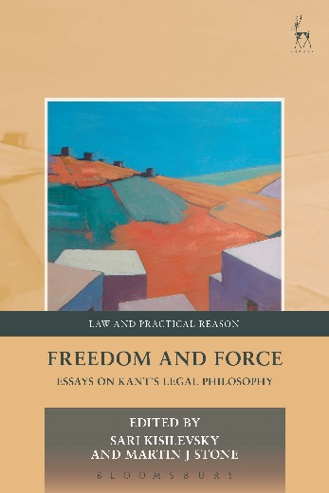
Freedom and Force
Essays on Kant’s Legal Philosophy
Edited by Sari Kisilevsky and Martin J Stone

This collection of essays takes as its starting point Arthur Ripstein’s Force and Freedom: Kant’s Legal and Political Philosophy, a seminal work on Kant’s thinking about law, which also treats many of the contemporary issues of legal and political philosophy. The essays offer readings and elucidations of Ripstein’s thought, dispute some of his claims and extend some of his themes within broader philosophical contexts, thus developing the significance of Ripstein’s ideas for contemporary legal and political philosophy.
All of the essays are contributions to normative philosophy in a broadly Kantian spirit. Prominent themes include rights in the body, the relation between morality and law, the nature of coercion and its role in legal obligation, the role of indeterminacy in law, the nature and justification of political society and the theory of the state. This volume will be of interest to a wide audience, including legal scholars, Kant scholars, and philosophers with an interest in Kant or in legal and political philosophy.

Sari Kisilevsky is an Assistant Professor of Philosophy at Queens College in the City University of New York.
Martin J Stone is Professor of Law in the Benjamin N Cardozo School of Law at Yeshiva University, and Adjunct Professor of Philosophy at the New School for Social Research.

Series: Law and Practical Reason
May 2017 | 9781849463164 | 240pp | Hardback | RSP: £65
Discount Price: £52

Click here to order online and use the discount code ODG at the checkout to get your 20% off

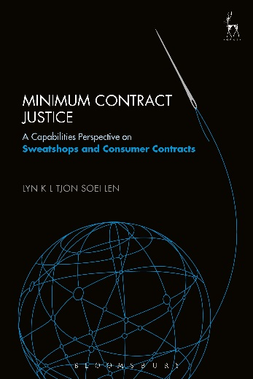
Minimum Contract Justice
A Capabilities Perspective on Sweatshops and Consumer Contracts
Lyn K L Tjon Soei Len

The collapse of the Rana Plaza in Bangladesh (2013) is one of many cases to invoke critical scrutiny and moral outrage regarding the conditions under which consumer goods sold on our markets are produced elsewhere. In spite of abiding moral concerns, these goods remain popular and consumers continue to buy them. Such transactions for goods made under deplorable production conditions are usually presumed to count as ‘normal’ market transactions, ie transactions that are recognized as valid consumer-contracts under the rules of contract law.

Minimum Contract Justice challenges this presumption of normality. It explores the question of how theories of justice bear on such consumer contracts; how should a society treat a transaction for a good made under deplorable conditions elsewhere? This Book defends the position that a society that strives to be minimally just should not lend its power to enforce, support, or encourage transactions that are incompatible with the ability of others elsewhere to live decent human lives. As such, the book introduces a new perspective on the legal debate concerning deplorable production conditions that has settled around ideas of corporate responsibility, and the pursuit of international labour rights.

Lyn K L Tjon Soei Len is an Assistant Professor of Law and International Feminist Studies in the Women’s Studies Program at the University of New Hampshire and a researcher at the Law School, University of Amsterdam.

May 2017 | 9781782257097 | 176pp | Hardback | RSP: £50
Discount Price: £40

Click here to order online and use the discount code ODG at the checkout to get your 20% off

